Project Status Report

GitHub Link - <https://github.com/anguyen72/SaveMore>

This is a link to my Github that contains my application code and py file for the code.

So far, I have written a code that includes all the requirements for this status report. I had a problem getting the code to run on pycharm. After reading the errors I figured out that the image files needed to be in the same directory as the py file. After getting the code to work, I had a baseline to work with. I need to do some testing to get the code just right for this report. For the interface, it works as expected. I am able to go to different windows and be able to go back to the main window. The Exit button works perfectly.

I will show screenshots of some testing showing the application works. Then I will show a problem I worked on and fixed after.

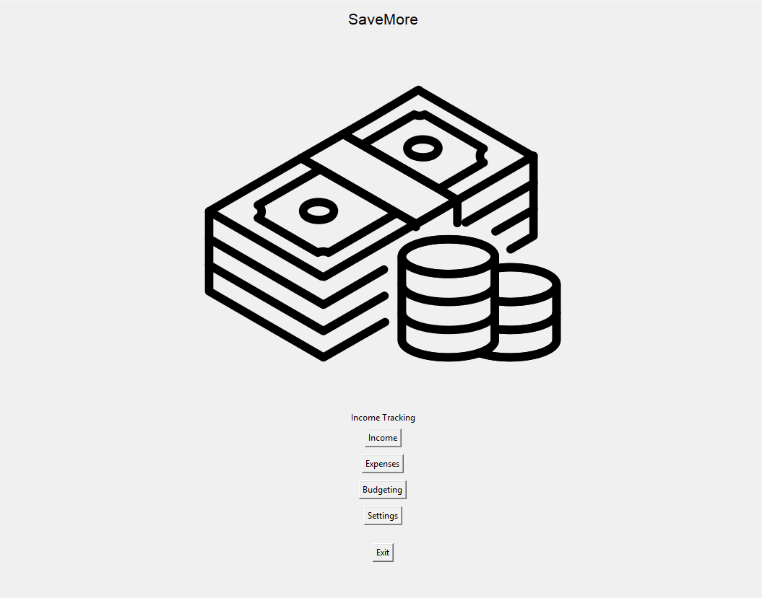

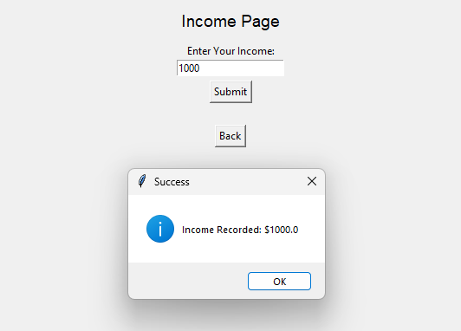

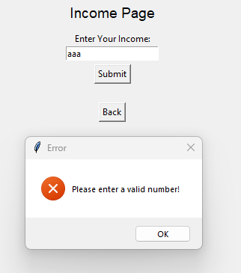

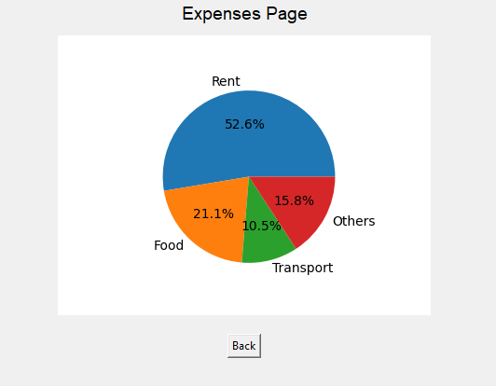

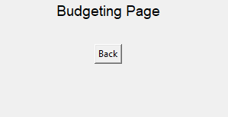

Now I will talk about a problem I have and how I fixed it. On the income page, letter or when nothing is imputed, there will be an error message telling you to input a number. With this, you are able to input a negative number shown here.

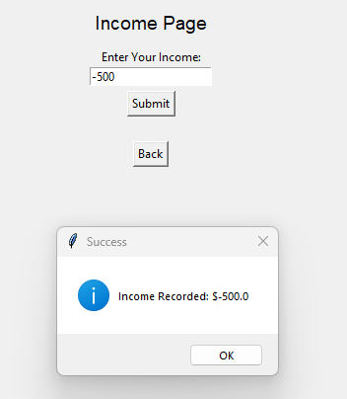

As seen, a negative number was able to be imputed which makes no sense. This was the old code for that section.

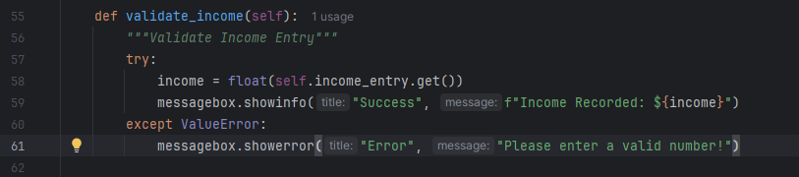

Now this is the new version and another screenshot of it working.

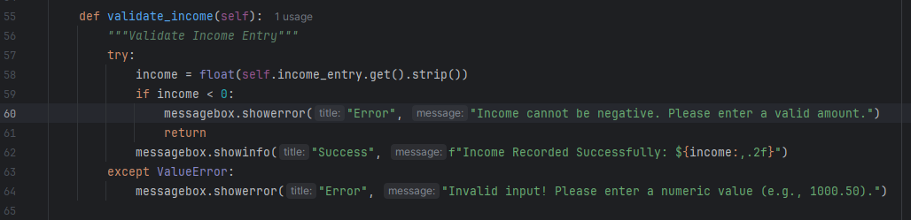

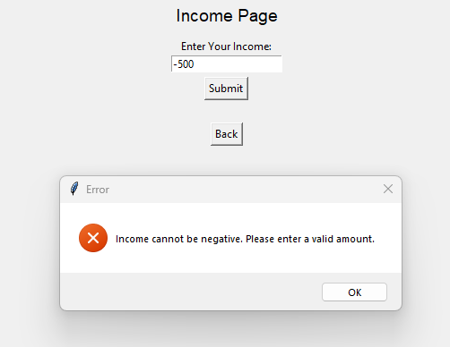

Now the application will not take any negative values.

The application was better than I expected. I need to continue to work on it and fill out the settings and budgeting windows. I'm not sure how I will use the settings windows and will do some research for inspiration. I have a good idea for the budgeting page. I want to allow the users to input values on how much money they want to budget for on expenses. For example, food, vehicles, and entertainment.